**The Art Dealer Game**

**Team Members Name**

**Niharika Akula**

**Nikhilesh Yadav Vanguru**

**ABSTRACT:**

"The Art Dealer Game" is an educational innovation designed to engage students from Kindergarten to 8th grade in a dynamic learning process. This report highlights the game's significance in nurturing critical thinking, pattern recognition, and strategic planning. It progresses through various difficulty levels, from basic color and shape recognition to complex data analysis, preparing students for real-world challenges. This report explores the game's design, methodology, and its impact on cognitive growth, acknowledging limitations. "The Art Dealer Game" offers an enjoyable and interactive learning experience, empowering students with valuable skills and a passion for exploration, making it a transformative educational tool.

**INTRODUCTION:**

The Art Dealer Game is a valuable learning process with the help of art. This game offers education for the students. This game will be helpful for the students as they advance from Grades K-2 to Grades 3-5 and further to Grades 6-8. Different age groups of students are involved in this game. For the young students in Kindergarten to 2nd grade, the game patterns are familiar like all-red or all-black cards, or specific suits like hearts or queens. As students progress to 3rd to 5th grade the challenges also become much more exciting. As the game progresses the student also feels a thrill in solving the steps. Apart from the thrill the Art Dealer Game is involved in critical thinking, pattern recognition, and strategic planning. This game is also helpful for a deep understanding of mathematical and logical concepts for the students. When an additional layer comes into the game the excitement of the students will increase.

In this report, we want to show that it is a game for young students. This report also shows the innovative learning patterns for the students. In this report, the mental condition of the students is also shown.

**OBJECTIVE:**

The kindergarten offers gameplay for young learners which is called the art dealer game. This game helps to learn about simple patterns of using cards. Through these games, kids increase their knowledge about colors and shapes. The art dealer game mainly introduces the different colors and shapes. This game comes with two cards which are red and black. These games help kids to notice how things are related, these skills allow kids to gain the understanding power regarding patterns in a fun way. These games have several grades, and as the level increases kids understand more complexity to understand the shape and pattern.Through this kids and students gain knowledge about the connection between patterns which is tricker. This game helps students to become experts in recognizing complex patterns. Throughout all these levels the art dealer game is not just about cards, this game helps students and kids to teach all those important skills which they can use in real life too. All those skills kids learn from these games such as making smart choices, even in tackling big piles of information.

This report wants to showcase the importance of learning about basic patterns, by observing this game kids can enhance their pattern recognition power. The report mainly focuses on the way kids grow their skills for real-world situations through this game. Also through this game kids and students can make smart choices in different situations.

**PROJECT OVERVIEW**

“The Art Dealer Game” is an innovative and engaging educational initiative at the point of cognitive skill, design recognition, and data analysis capabilities among game players of different grade levels. The overview of this paper is to provide game players with a stimulating and interactive platform that fosters critical thinking, observation, and crafting an engaging game that adapts to varying levels of complexity to grasp fundamental concepts while nurturing their confidence to tackle more intricate challenges. In this paper, its core innovation lies in its three-tiered learning progression catering to different age groups. In the K-2 level, the young students explore concepts such as colors, suits, and basic card attributes. Recognizing patterns like all red, all black, or specific suits like hearts or queens, these budding learners engage in the playful introduction to pattern recognition. At the grades 3-5 levels, mature students transition to more complex patterns that challenge their analytical skills. Concepts like prime numbers and card combinations adding up to specific values encourage critical thinking and data interpretation. At the last grade 6-8 level, the paper immerses students in the realm of local and big data. Graph generation, poker combinations and the ability to big data based on their decision introduce them to the real world of data analysis. This level also encourages collaborative learning, allowing students to play the game against each other. Beyond the gaming environment, this paper underscores the importance of data analysis in the modern world. By introducing the concepts early on, learners not only gain a competitive edge in problem-solving but also prepare themselves for a data-driven society where critical hiking and pattern recognition are indispensable skills. The view of the paper is to offer an engaging and enjoyable learning experience that promotes cognitive growth. It aims to empower students with skills that extend far beyond the game, fostering a deeper understanding of data, patterns, and informed decision-making.

**PROJECT DESIGN**

“The Art Dealer Game” aims to comprehensively investigate the effectiveness of the game in enhancing pattern recognition in different grade levels and its impact on enhancing game players' cognitive skills. This paper also adopts a systematic approach to outline the research objectives, methodology, findings, and implications on different levels of the game. Game players are tasked with unraveling the preferences of an art dealer by strategically presenting sets of four playing cards from a standard deck of 52 (Sommerville, 2020). The central premise is to decipher the patterns that attract the art dealer’s interest. The game is ingeniously designed to progress through three distinct levels seamlessly aligned with varying grade levels: k-2, 3-5, and 6-8. This deliberate progression ensures that players gradually transition from basic pattern recognition to more intricate data analysis, effectively minimizing the learning curve as they advance through their learning journey. At the K-2 levels, game players are introduced to fundamental patterns that are simple to compare. Design Such as groping all red or all black cards or identifying cards of the same suit. Develop basic pattern recognition skills. The grade 6-8 level of the game is too dynamic; the interaction of playing peers as art dealers or sellers amplifies the experiential learning, fostering collaboration and strategic thinking. For this game design, we used Python programming. We attached a few screenshots of the visual gaming for the K-2 level.



This image shows how to start the game on the art dealer game visually



The image shows the size of the gaming interface

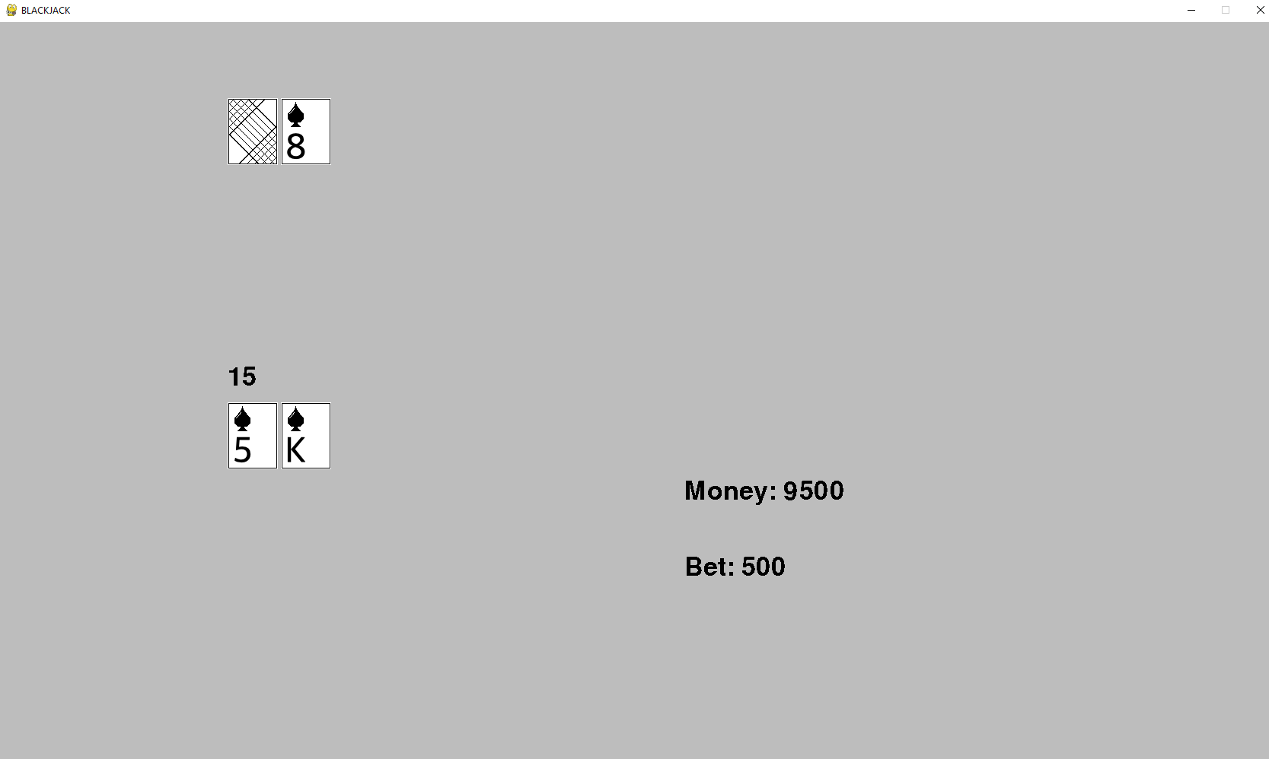

This visual image shows how to play game



This image shows the final result of the game for the K-2 level

**METHODOLOGY:**

In this paper “The Art Dealer Game” is carefully designed to facilitate a gradual educational journey for different grade levels of students while providing interactive and important thinking. The effectiveness of this game is situated in engaging dynamics, structural progression, and real-world relevance. This game structure progresses through K-2, Grades 3-5, and Grades 6-8 distinct phases. In the K-2 phase, simple patterns like card shapes, and colors initiated the early pattern recognition. Grades 3-5 introduce game challenges, a prime number of cards can add many specific values. However, Grades 6-8 define an intricate poker-like pattern and handle a large number of data sets to reflect real-world scenarios.

In this cultivating interactive learning is essential and the student can actively participate by observing the art dealer game' performances and selecting cards. In this game, the grades 6-8 peer interaction of elements is critical. The student can take turns as the art dealer and seller to develop adaptability and thinking strategy for this real-world data analysis. More importantly, the methodology helps in skill progression to facilitate smoother transitions of intricacies challenges. Furthermore, to develop this game we have used the Python method that helps to generate and manage the pattern of different game levels (Tchitanava, et al. 2023). Also ensures an accurate and consistent pattern formation as it increases the complexity. Therefore this comprehensive approach helps to provide the students with valuable skills and enables them to solve the complexities in-game scenarios.

**RESULT:**

Developing an educational game like this helps to sharpen one's own skills. Balancing the educational goals with engaging in gameplay improves the expatriates in game development and also with real-world knowledge. The additional features of the developments can help students to set their abilities of problem-solving. In our development process of these games, though this game students can build their technical and design analysis power, this game offers a way to teach complex concepts, and this sense of purpose can bring great satisfaction (Kim, 2023). Our team has developed a successful game that meets the market needs and demands, and will also help the parents, teachers, and schools who seek effective educational tools for their children.

**LIMITATION:**

“The Art Dealer Game” provides many valuable educational benefits while it still can have some limitations. Basically, this game’s initial stages include the younger students while it does not potentially include the older ones. For some learners, the transition between the levels is not consistent which causes frustration. Rather than focusing on neglecting areas such as problem-solving and spreading the skills of creativity and spreading skills, this game focuses on data analysis and design pattern recognition. Additionally, this game’s virtual nature does not provide any hands-on experience with real-world applications, missing opportunities to increase decision-making skills and educational impacts might provide confidence to the game itself.

**CONCLUSION:**

For the students, The art Dealer game is a playing activity. In this world of learning, the Art Dealer Game offers a refreshing and transformative alternative. It celebrates the joy of discovery, the thrill of competition, and the satisfaction of unraveling in the mind of the student. The student passes through this education journey with the help of this game. With the help of this game, the students not only become masters of cards but also become masters of essential skills. The game will be beneficial for constructing the life of students. This type of game will help the students in the future and it will also enhance their thinking capability. Here we have developed a game in the name of The Art Dealer Game. This game will be also helpful in shaping the mindset of the students.

**REFERENCES**:

Hagberg Enea, P. (2023). The Influences of Concept art: How is game concept art connected to earlier art movements?.

Tchitanava, N., Tchitanava, L., Beridze, D., & Chxirodze, B. (2023). PYTHON USE IN GAMING. *Scientific and practical cyber security journal*.

Sommerville, I. (2020). Engineering software products (Vol. 355). London, UK: Pearson. Hagberg Enea, P. (2023). The Influences of Concept art: How is game concept art connected to earlier art movements?.

Kim, J. (2023). PokerKit: A Comprehensive Python Library for Fine-Grained Multi-Variant Poker Game Simulations. arXiv preprint arXiv:2308.07327.